Earth Science
Lab Techniques

Name:_________________________________

Date:__________________________________

Partners:________________________________

Using proper lab techniques and safety is extremely important for scientists. Proper techniques ensure a safe environment, as well as minimize accidents and mistakes to samples. Please complete the following stations to learn how lab techniques we will be using throughout the class.

Station 1
Transferring Liquids

Step1:
On the piece of paper labeled “Transferring Liquids”, write neat and large one step on how to dilute a solution with a stirring rod pour. If you are the first group at this station, write the first step. If you are not, write the next step in order. Feel free to draw or decorate your step – these will be placed on display. If all the steps are taken, decorate!

Step 2:
In order to “pass” the transferring liquids station, Ms. Bond MUST be watching to ensure correct methods. After she confirms you did it correctly, you may practice more.

- Read the label at least three times before using the contents of a bottle.
- Never lay the stopper of a reagent bottle on the lab table.
- When pouring a caustic or corrosive liquid into a beaker, use a stirring rod to avoid drips and spills. Hold the stirring rod against the lip of the reagent bottle. Estimate the amount of liquid you need, and pour this amount along the rod, into the beaker. See Figure G.
- Extra precaution should be taken when handling a bottle of acid. Remember the following important rules: Never add water to any concentrated acid, particularly sulfuric acid, because the mixture can splash and will generate a lot of energy as heat. To dilute any acid, add the acid to water in small quantities while stirring slowly. Remember the “triple A’s”—Always Add Acid to
- Examine the outside of the reagent bottle for any liquid that has dripped down the bottle or spilled on the counter top. Your teacher will show you the proper procedures for cleaning up a chemical spill.
- Never pour reagents back into stock bottles. At the end of the experiment, your teacher will tell you how to dispose of any excess chemicals.

Station 2
Measuring Volume

Step 1:
On the piece of paper labeled “Measuring Volume”, write neat and large one step on how to measure volume with a graduated cylinder. If you are the first group at this station, write the first step. If you are not, write the next step in order. Feel free to draw or decorate your step – these will be placed on display. If all the steps are taken, decorate!

Step 2:
In order to “pass” the measuring volume station, Ms. Bond MUST be watching to ensure correct methods. After she confirms you did it correctly, you may practice more.

A graduated cylinder is a cylindrical glass (or plastic) tube sealed at one end with a calibrated scale etched (or marked) on the outside wall. They come in a range of sizes (volume capacities), and much like a measuring cup, volume is measured by adding liquid to the cylinder and comparing the liquid level to the graduated scale.
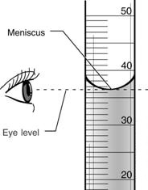
Practice pouring out particular amounts of liquid into the graduated cylinder.
- Grab the top of the graduated cylinder firmly and slowly pour 25mL of liquid from the beaker into the cylinder.
- View the amount of liquid in the cylinder at a right angle from your eye.
- Liquid in a glass cylinder will have a curved surface, called a meniscus. Read the volume of the liquid from the bottom of the curve of the meniscus, as shown to the right.
- Always place the glass cylinder on its side when not in use. This will prevent it from falling and breaking.

Station 3
Measuring Mass

Step 1:
On the piece of paper labeled “Measuring Mass”, write neat and large one step on how to measure mass with a Dial-O-Gram balance. If you are the first group at this station, write the first step. If you are not, write the next step in order. Feel free to draw or decorate your step – these will be placed on display. If all the steps are taken, decorate!

Step 2:
In order to “pass” the using a scale station, Ms. Bond MUST be watching to ensure correct methods. After she confirms you did it correctly, you may practice more.

The primary method that you will use to measure the amounts of chemicals or weight of materials is to determine their mass. To do this you use a Dial-O-Gram balance.
In reading the weight on the dial, there are two sets of numbers to work with, the numbers on the dial itself and the numbers on the stationary plate above it. You will read the weight based on where the 0 on the stationary plate is located. Further explanation will be in the steps below.

50g weight
100g weight
Dial

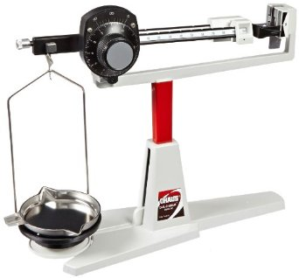

Pan

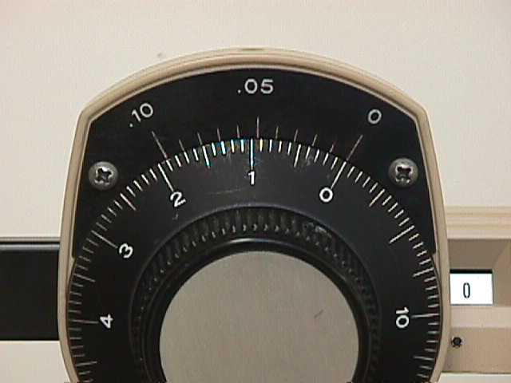
- See that the balance pan is in place and the weights and dial are all set at zero (dial shown on the right).
- Note where the pointer points on the scale at the far right of the balance. This is the "zero point" or "balance point." If the pointer is not near the center of the scale, let an instructor know so that we can get it adjusted. If it is off just a little bit, make a note of where it is and weigh to that point.
- Get a small beaker.
- Put the beaker on the balance pan and weigh it by the following procedure:
  - Move the 100 gram weight to the right one notch at a time until the pointer goes below the balance point.
  - Then move it back to the left one notch. Make sure that it is in a notch.
  - Next, move the 10 gram weight to the right one notch at a time until the pointer goes below the balance point.
  - Then move it back to the left one notch.
  - Next, turn the dial until the pointer lines up with the balance point again.
  - Record the weight of the beaker. This requires that you add up the weight values shown by both sliding weights and the dial. In this case below it is 28.87 g.
Weight of your beaker:

______________
Weight of your rock and beaker:

______________
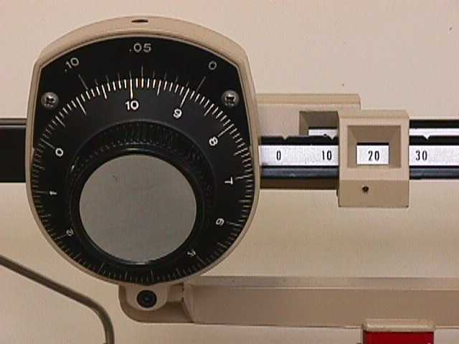

- Put the rock in the beaker. Adjust the weights and dial to bring the balance pointer back to the balance point and then record the total weight shown there to the nearest 1/100th of a gram as we just discussed.
- The weight of the rock is the difference between the total weight and the weight of the beaker. It can be obtained by subtracting the weight of the container from the total weight.
Weight of your rock = Weight of your rock and beaker – Weight of your beaker

_______________ = _________________________ – ________________

- The last step is to clean up anything you might have spilled and to return the weights and dial to zero.
Station 4
Using a Bunsen Burner

Step 1:
On the piece of paper labeled “Using a Bunsen Burner”, write neat and large one step on how to properly light a Bunsen burner. If you are the first group at this station, write the first step. If you are not, write the next step in order. Feel free to draw or decorate your step – these will be placed on display. If all the steps are taken, decorate!

Step 2:
The first time you use a Bunsen burner, Ms. Bond MUST be watching to ensure correct methods. After she confirms you did it correctly, you are welcome to practice more.

Read through the following instructions. Once you are confident you know the steps by heart, raise your hand for Ms. Bond to come over and watch you light your Bunsen burner.

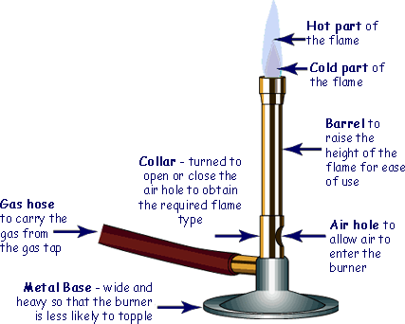

- The Bunsen burner has rubber tubing attached to it. The other end of the rubber tubing needs to be firmly attached to the gas tap on your bench. It is very important that you check this tap is in the 'off' position before you attach your Bunsen burner.
- Once you have secured the rubber tubing to the gas tap you should check that its air holes are closed. If they are open, just rotate the metal collar to close them
- Practice with the striker: To use, hold midway, near the "bumps" in the middle of the wire, and squeeze. The first time you try it, hold the striker flint-side up to see if sparks are produced. If sparks are produced, you did it right.
When using to light a Bunsen burner, turn the striker over and hold over the top of the burner with the gas light turned lightly on. Some gas will collect under the cap, and will ignite when sparks are produced.
- Turn your gas tap to the 'on' position
- As soon as the gas tap is open, quickly place your striker directly above the top of the burner and strike it.
- The Bunsen will light to give a yellow safety flame. You must never use the yellow safety flame to heat something. Before you can heat something you must open the air-holes by turning the metal collar. The more the air holes are open, the fiercer the Bunsen flame. Your teacher will advise you on which type of flame you will be using.

WARNING: Anything you have been heating and the burner itself will be very hot. You must leave the apparatus to cool down before you put it away.

- When you have finished using your Bunsen burner you must turn off the gas by pushing the tap down and turn it 90° to its 'off' position.

